Comment Service & HATEOS:

1.First Message Creation:

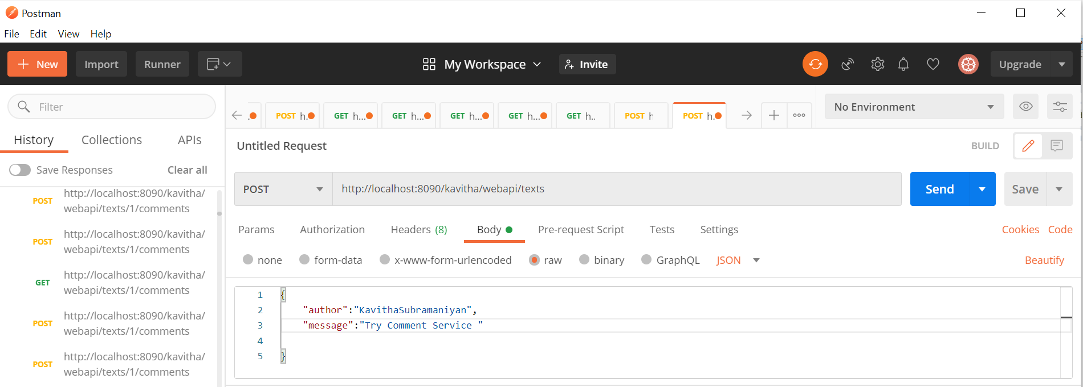

Checking if the above message is created.

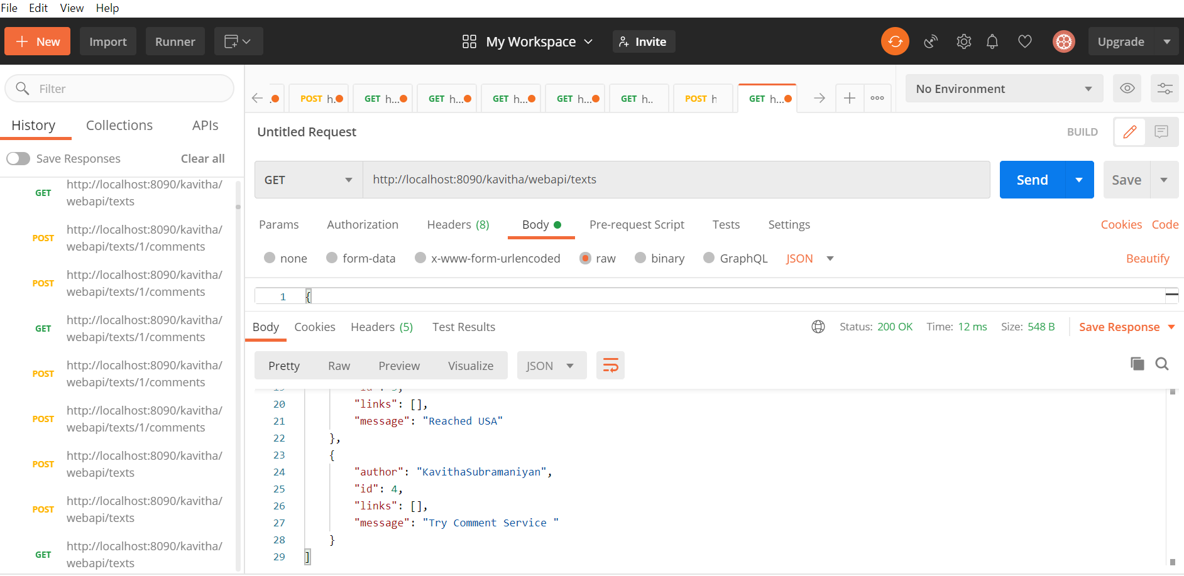



Insert comment1 under this author “KavithaSubramaniyan” and id=4

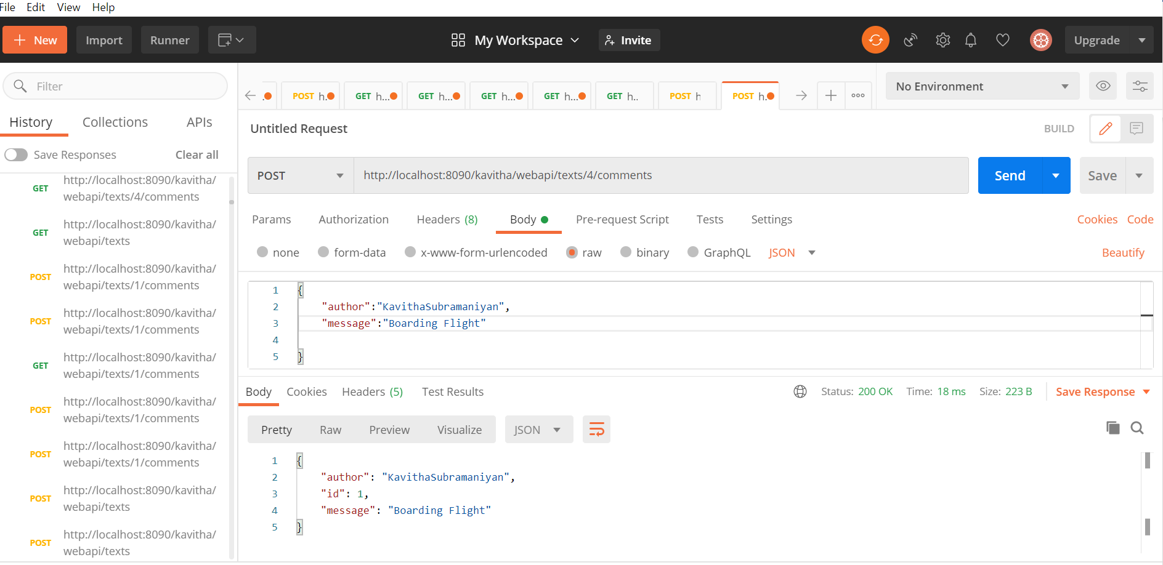



Creating 2nd comment under the same message and author

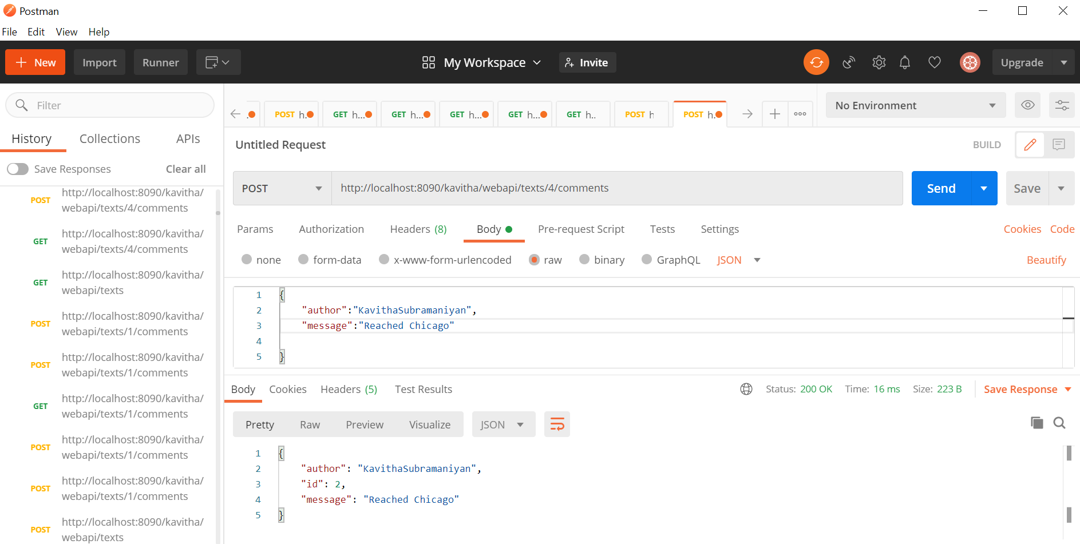



Viewing the created comments using ‘GET’ method:

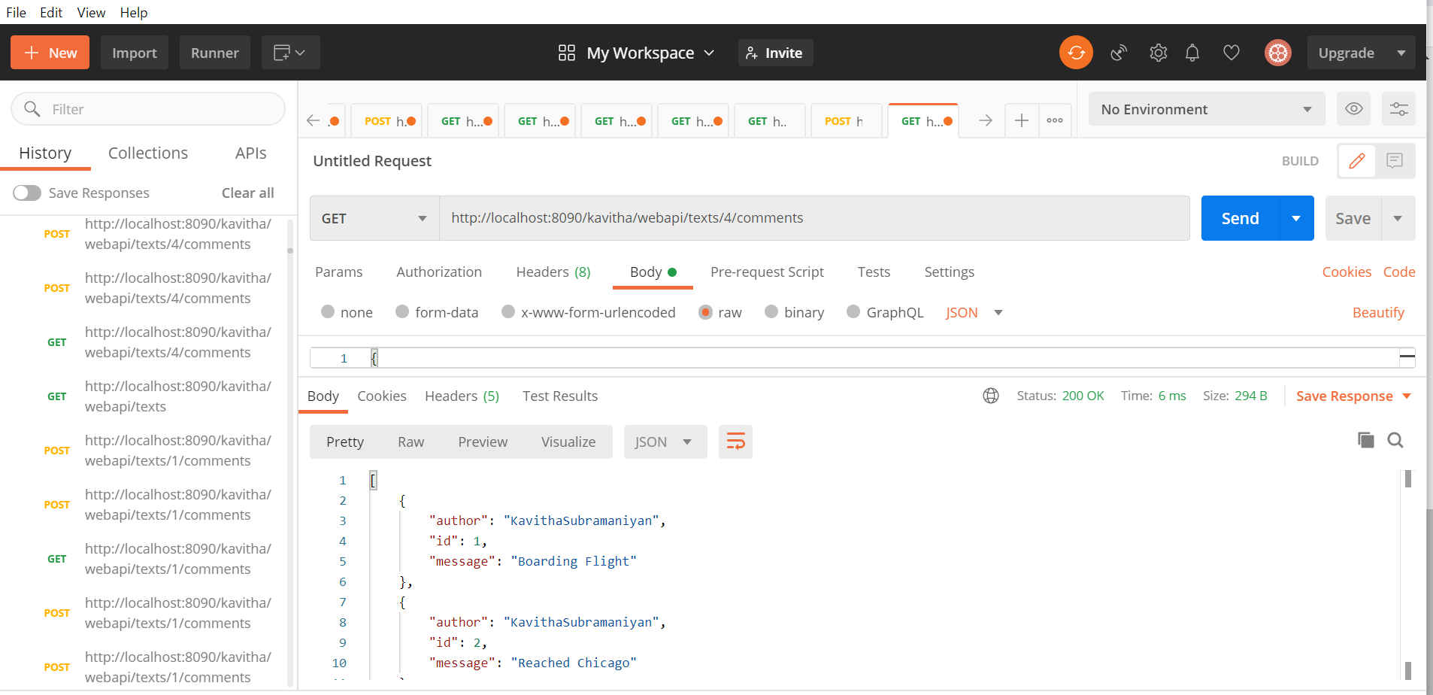



Update the First Comment of the id=4 using ‘PUT’:

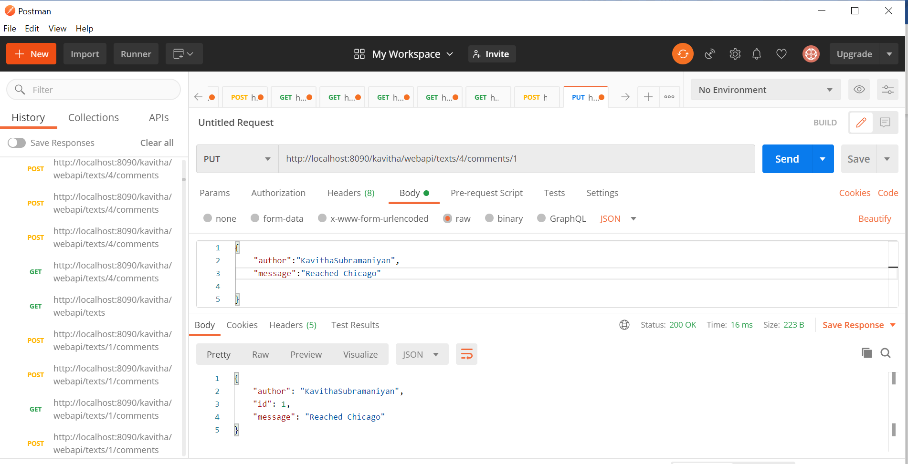



Checking if the comment is updated for first comment(id=1) under user=kavithasubramaniyan and id=4

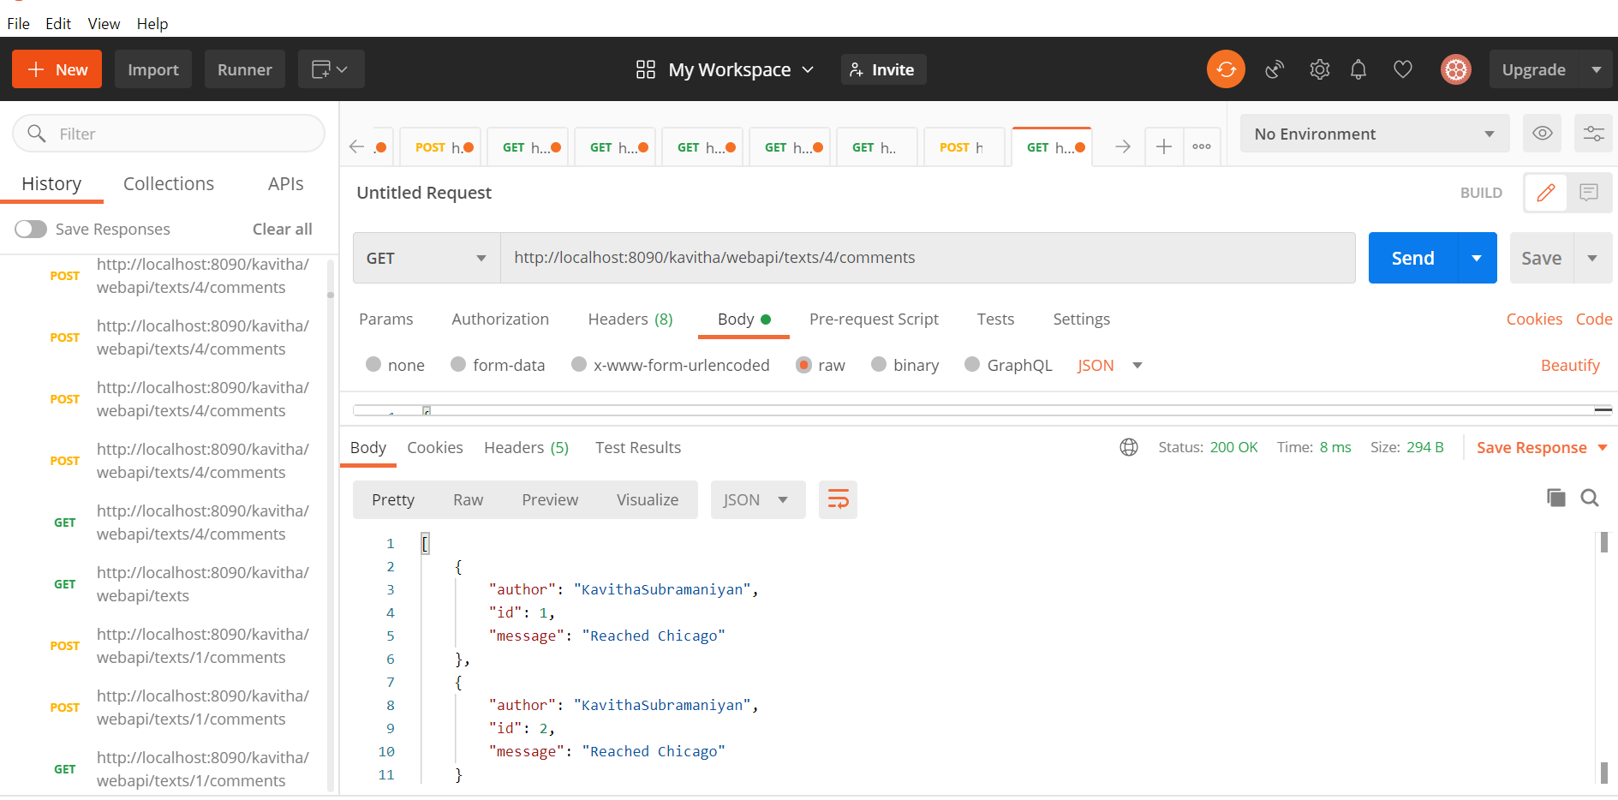

Create third comment and delete it:

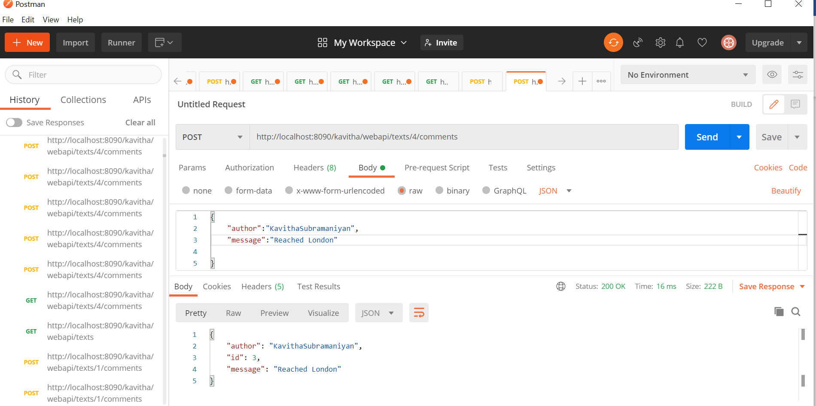

List the comments now,

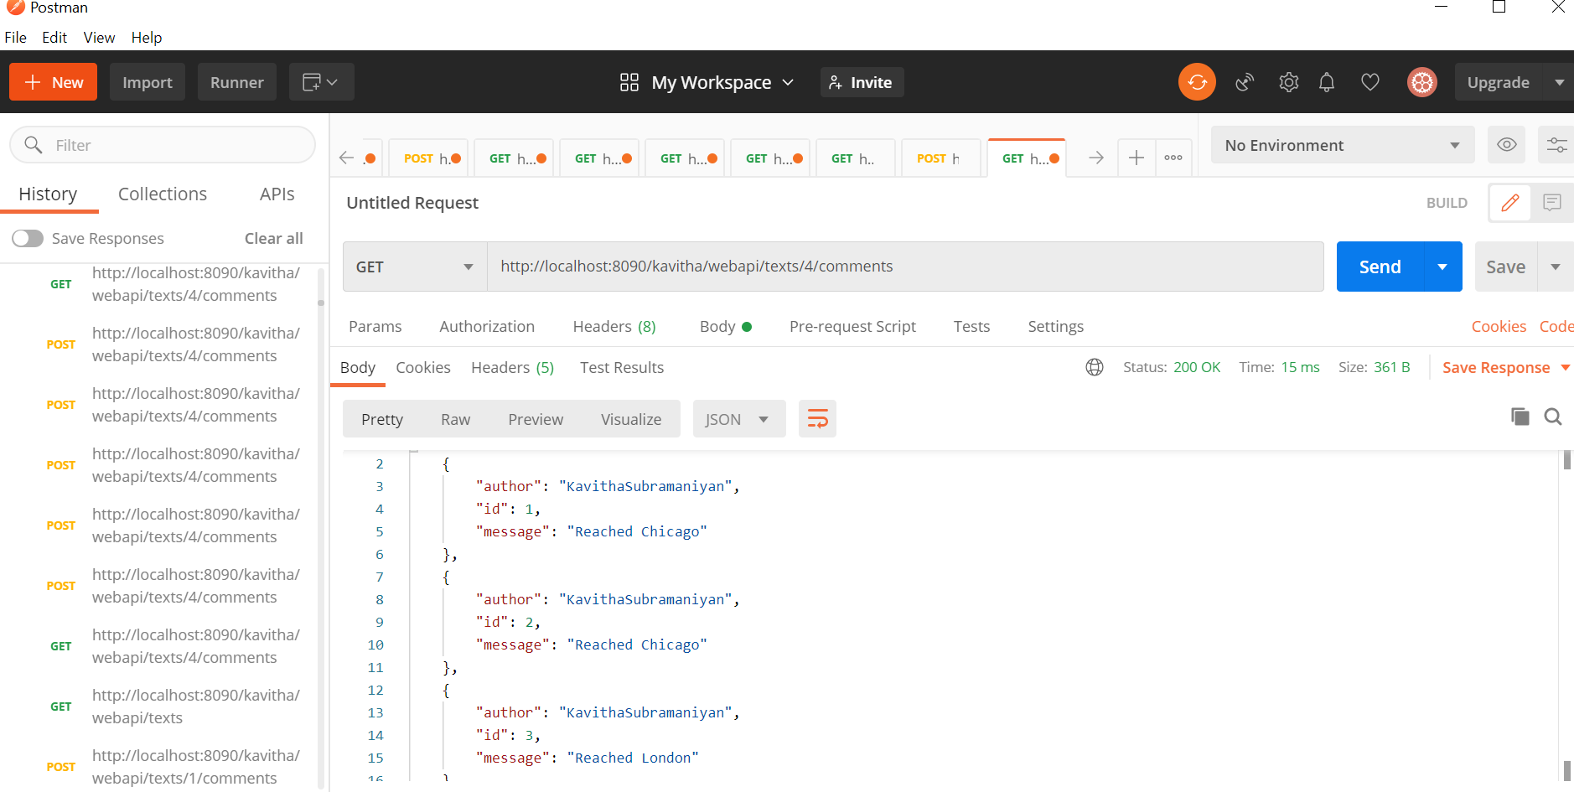

Delete the third comment now,

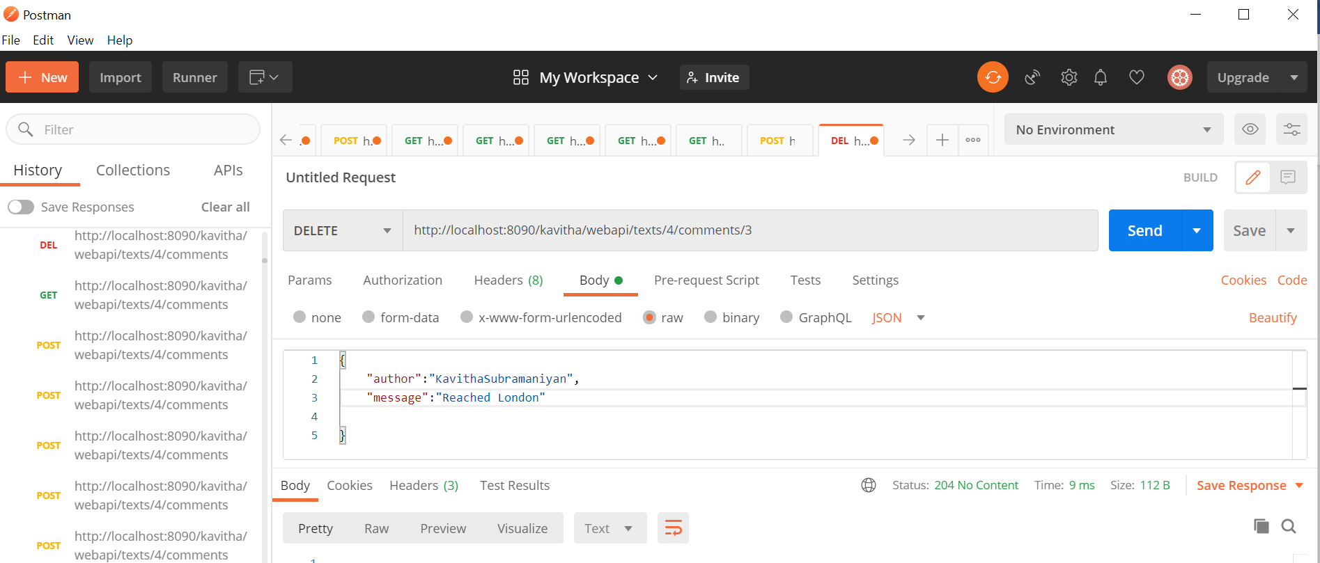

After deleting the comment3,now again view the list of comments using ‘GET’

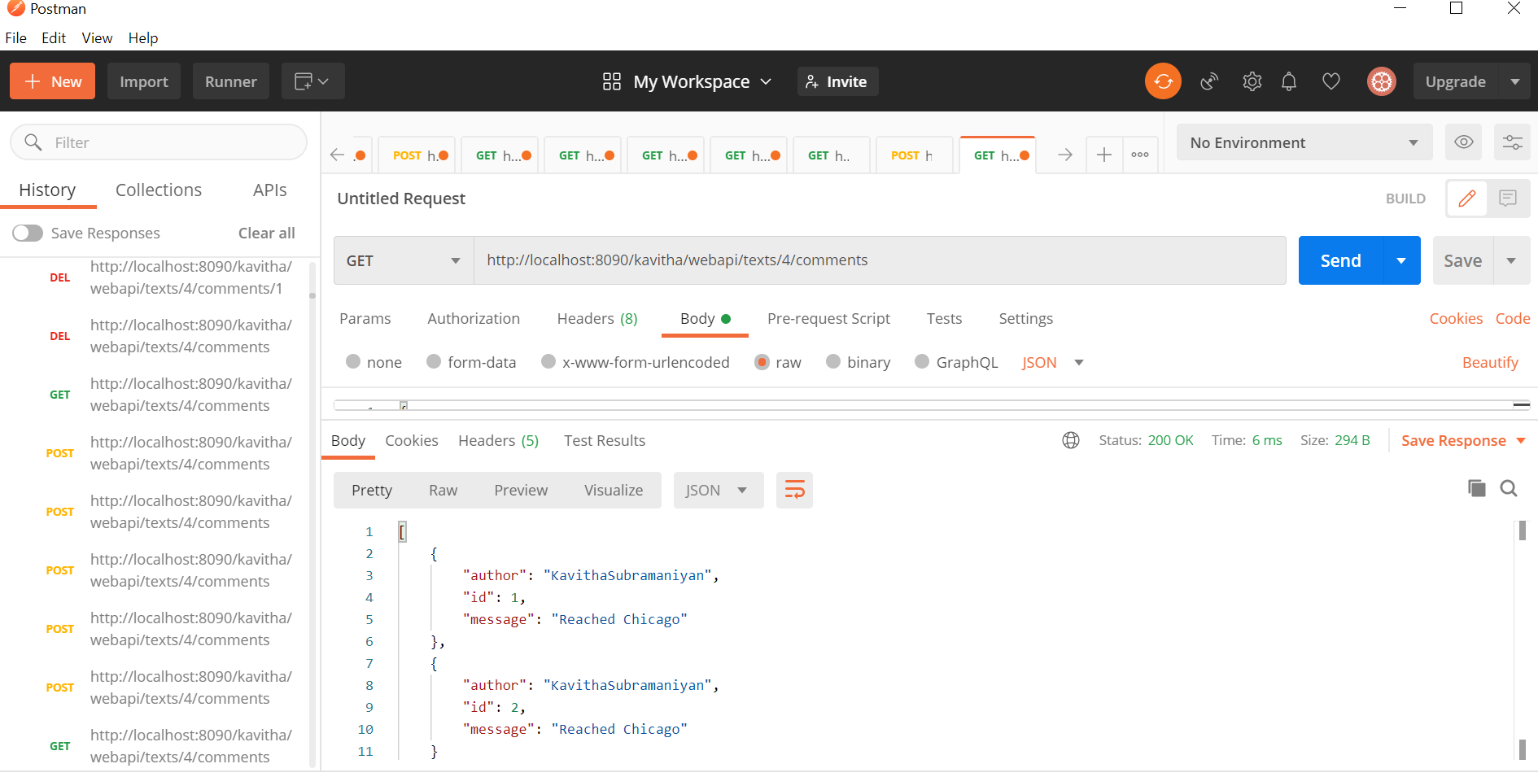

Creating the second message:

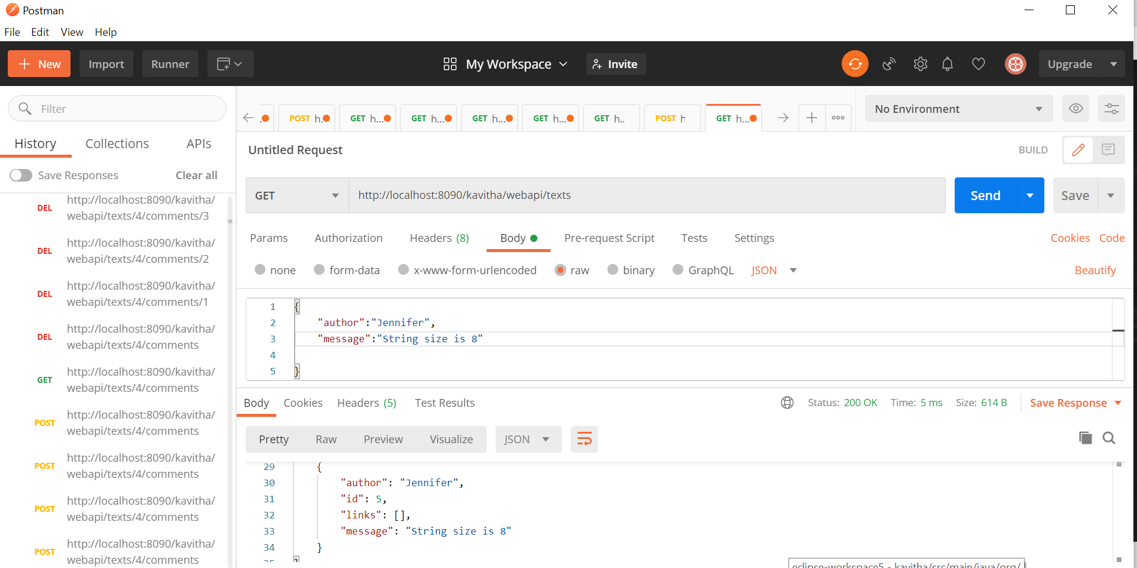

Empty List as comments are not added for the new message creation.

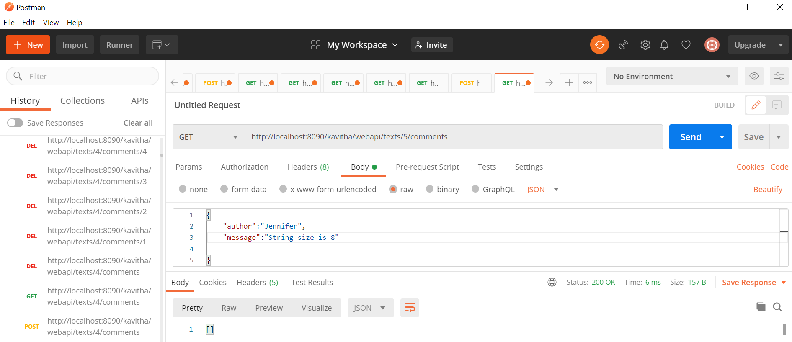

Create comments for the id=5

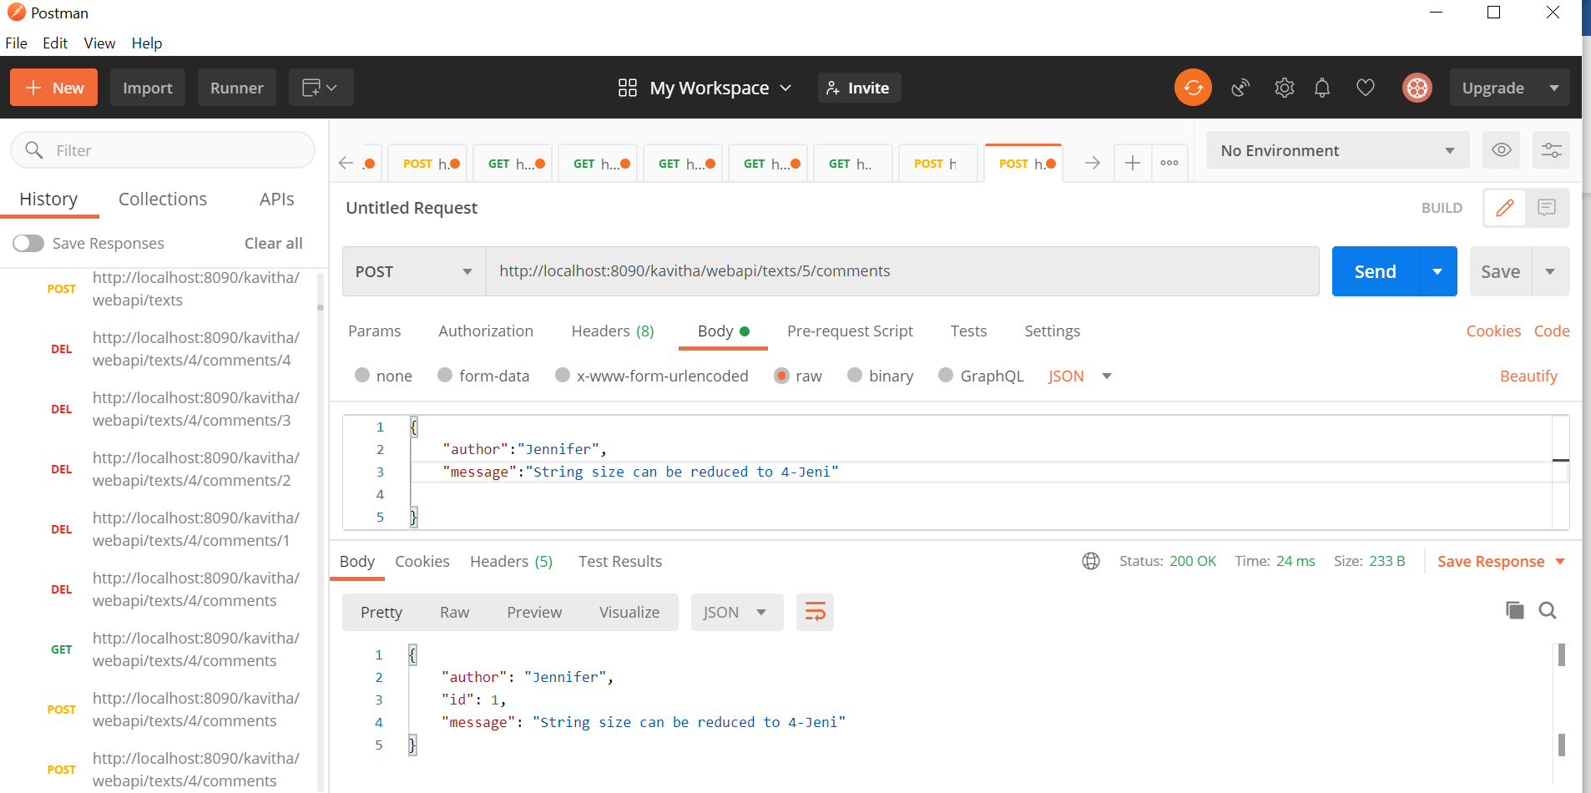

Create second comment for id=5

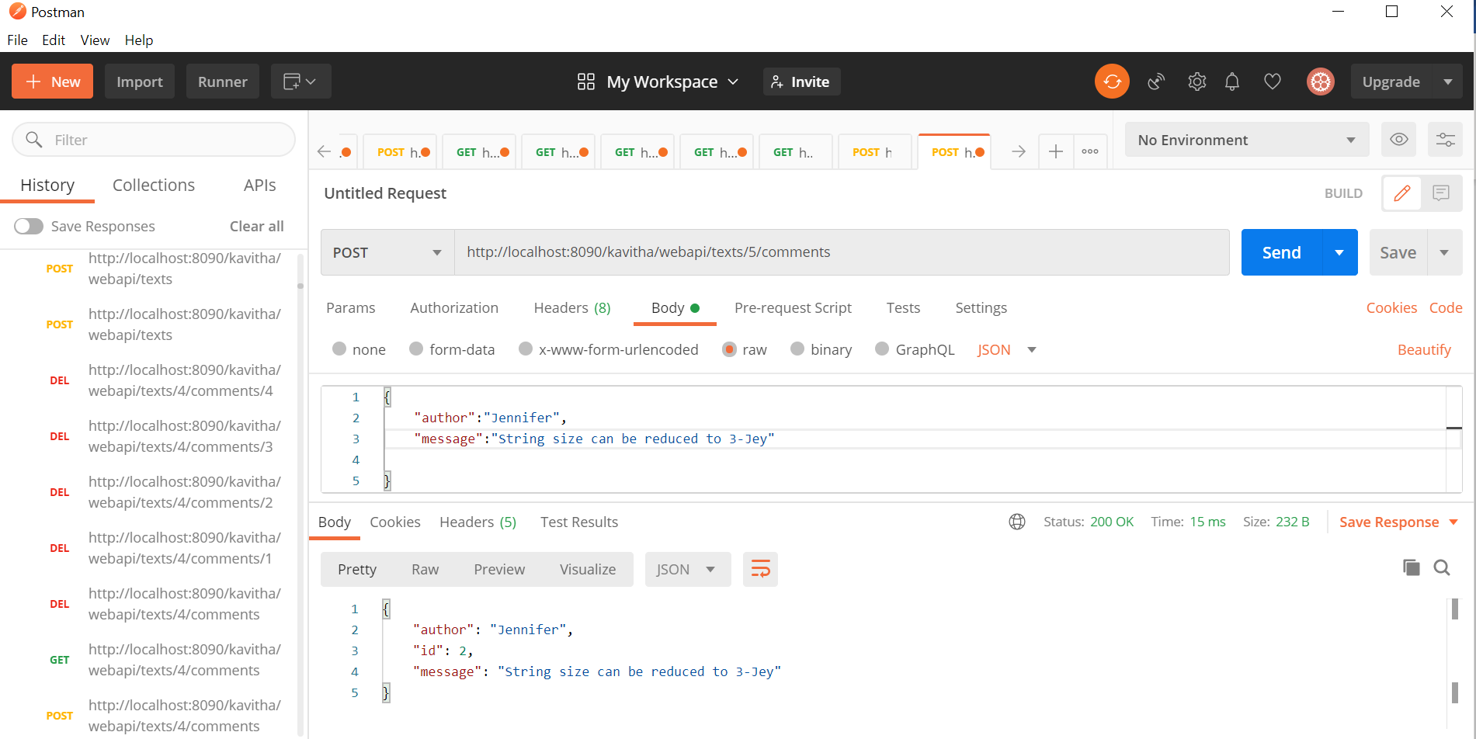

List of comments:

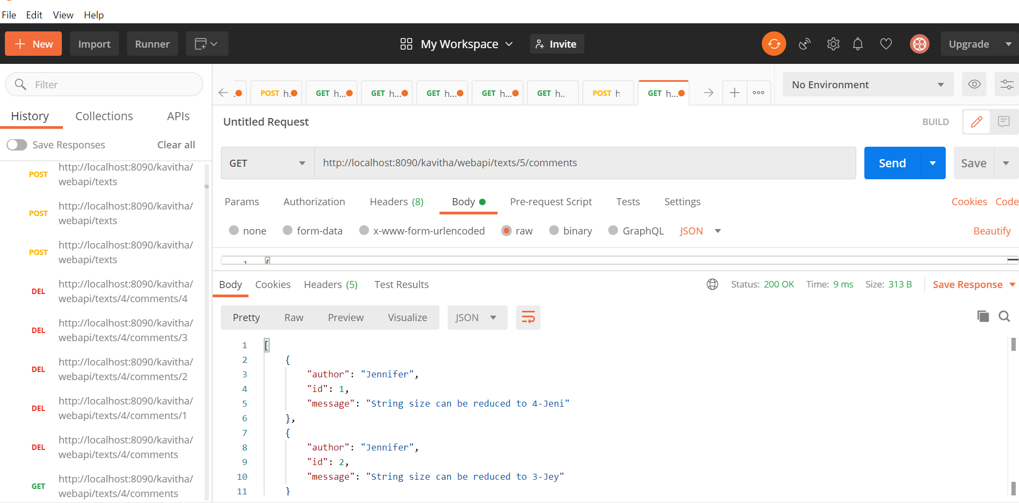

Creating third message and viewing it:

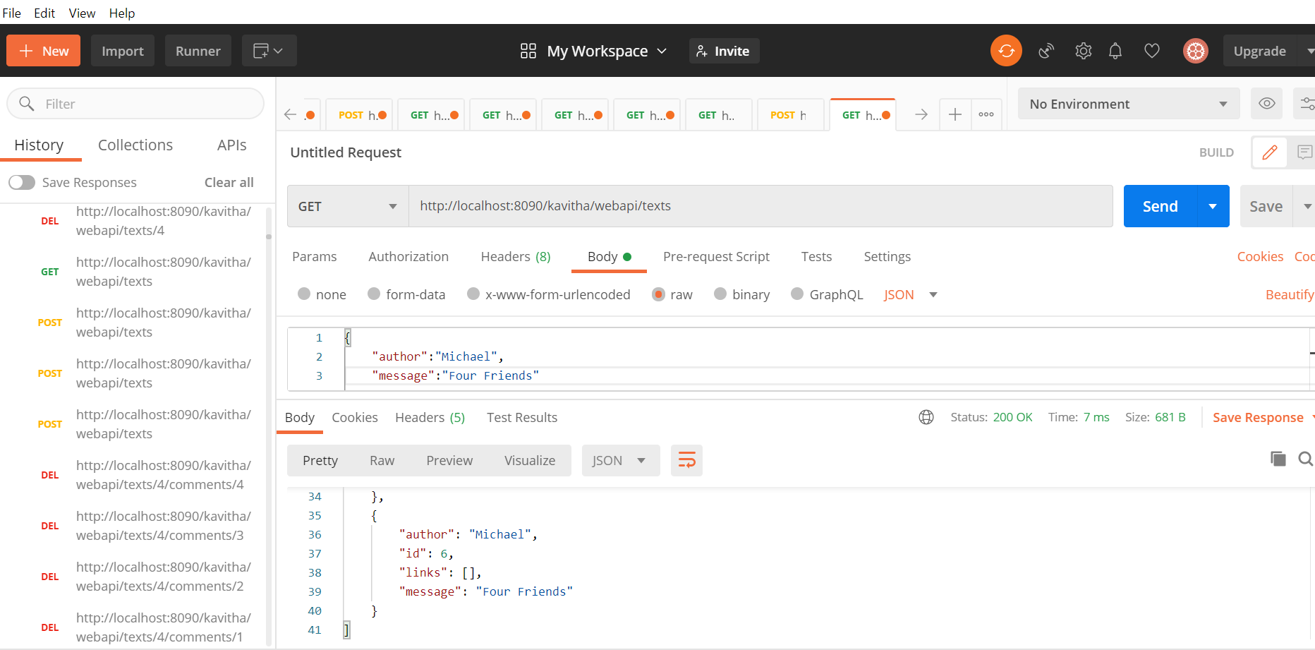

Creating first comment under third message:

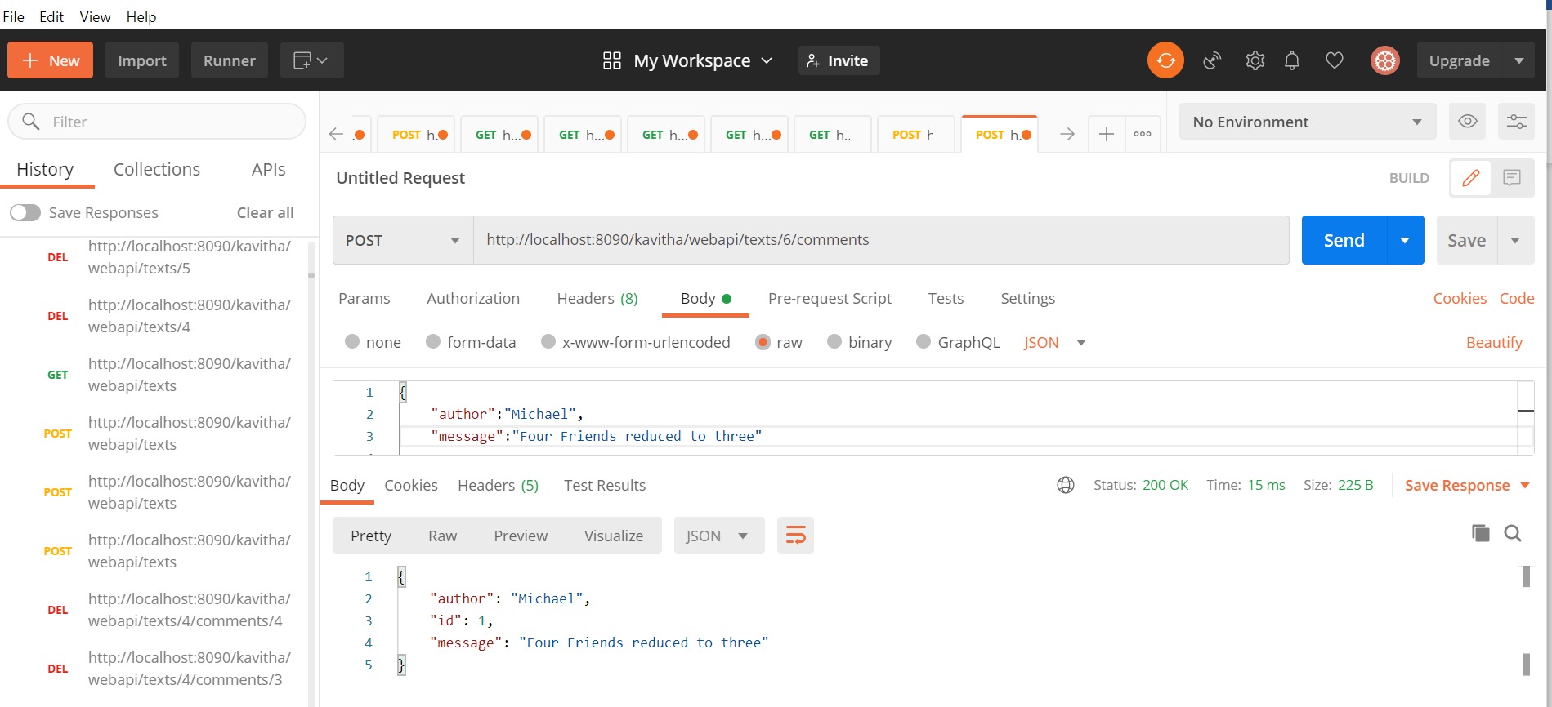

Creating second comment under third message,

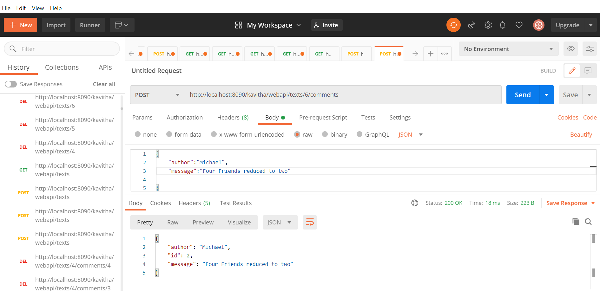

Viewing the list of comments under id=6

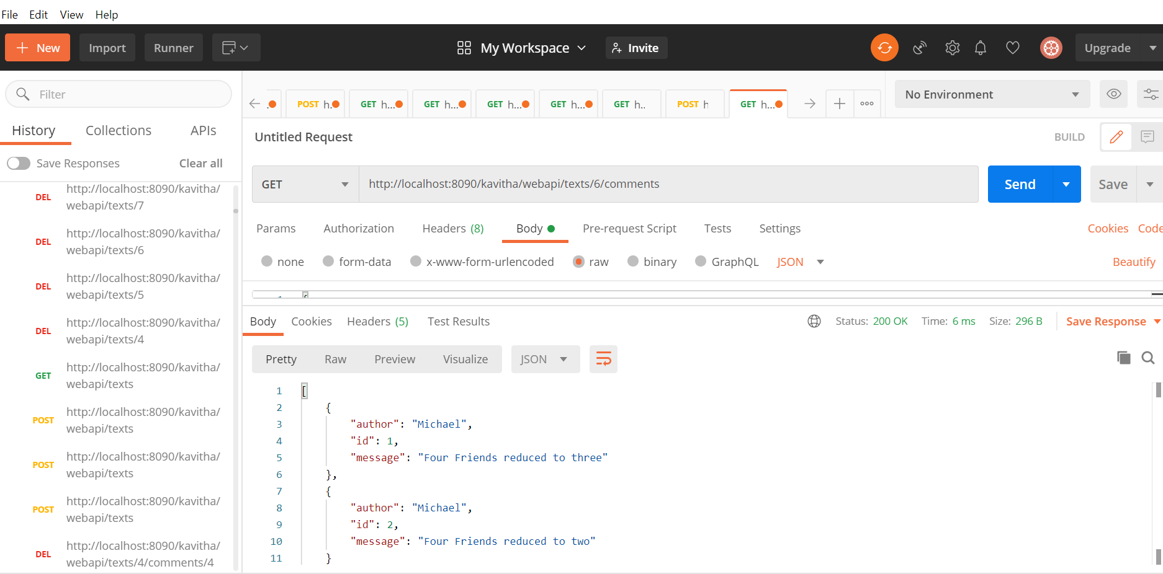

Updating the comment now,

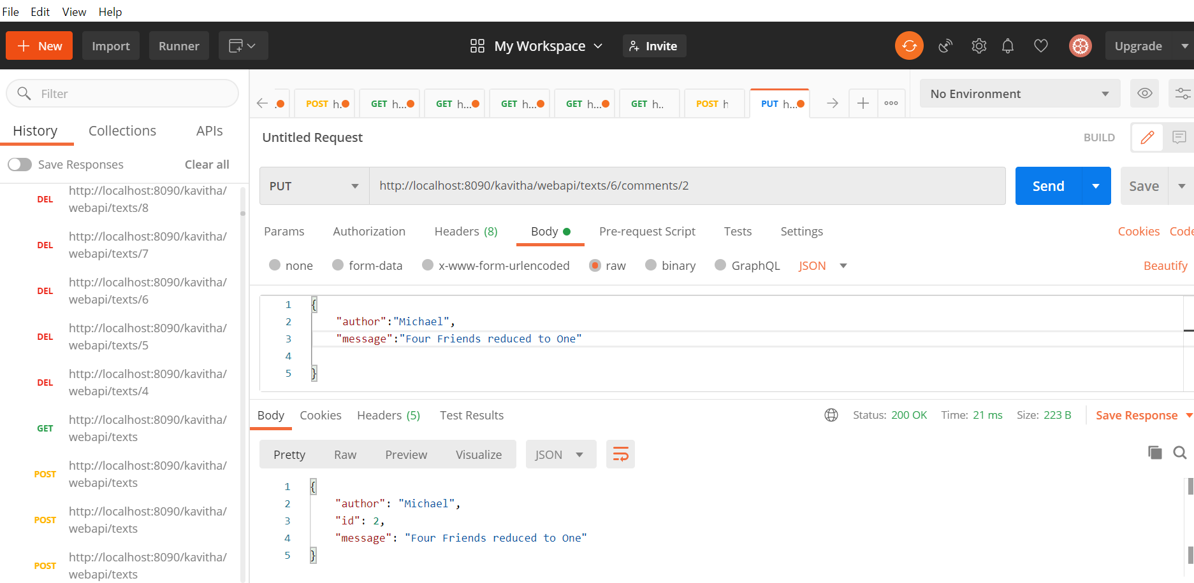

Viewing the changes:

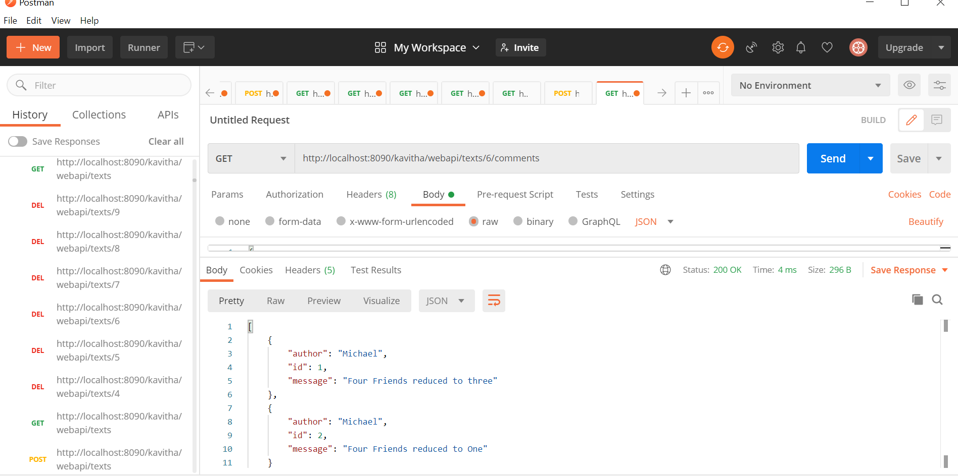

Deleting the second comment now:

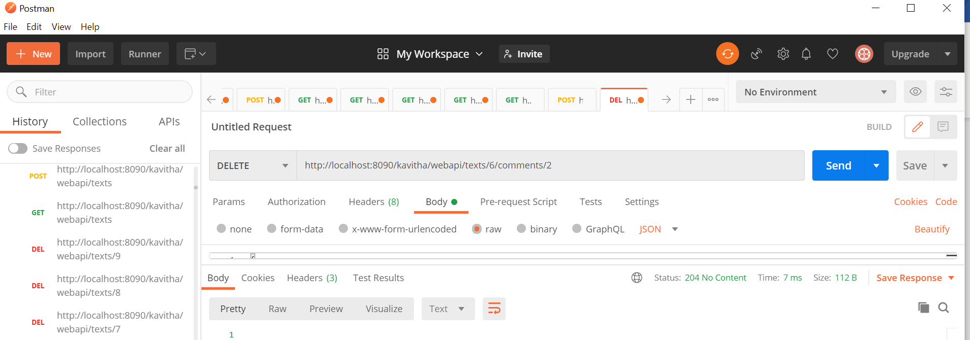

Viewing the list of comments now (after deletion):

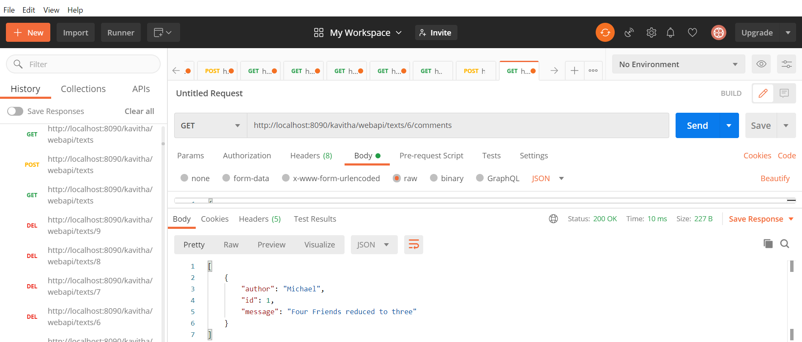

Display hyperlinks using HATEOS:

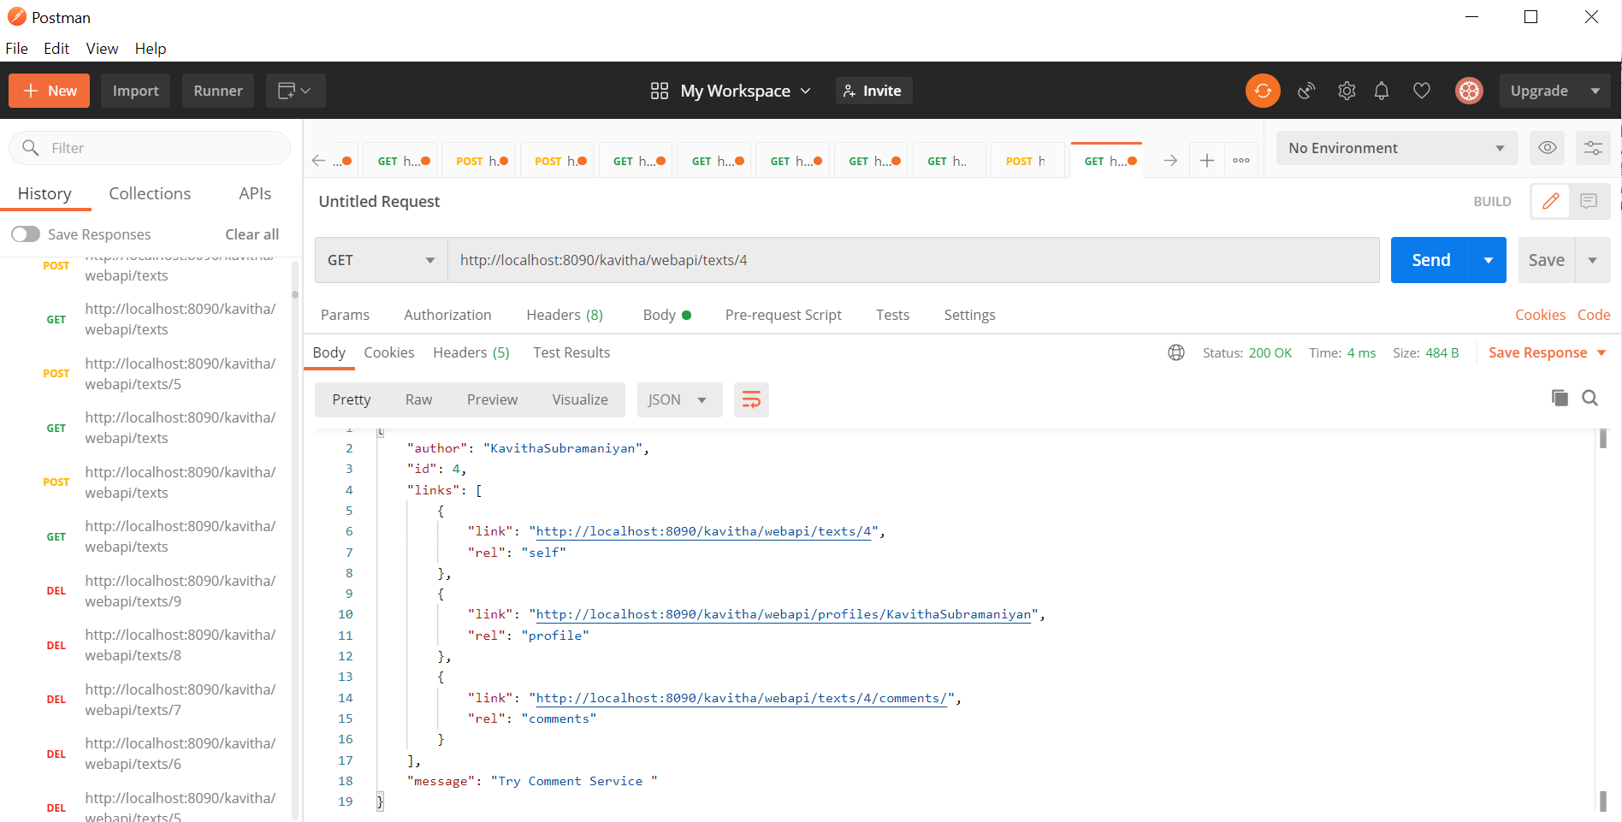

Viewing the comments hyperlink in the browser:



Viewing the ‘self’ hyperlink in the browser:

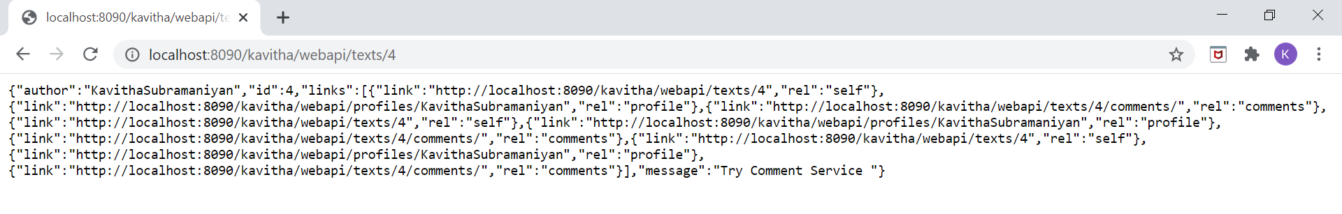

Viewing the profiles hyperlink in the browser:



HATEOS for 2nd message with two comments:

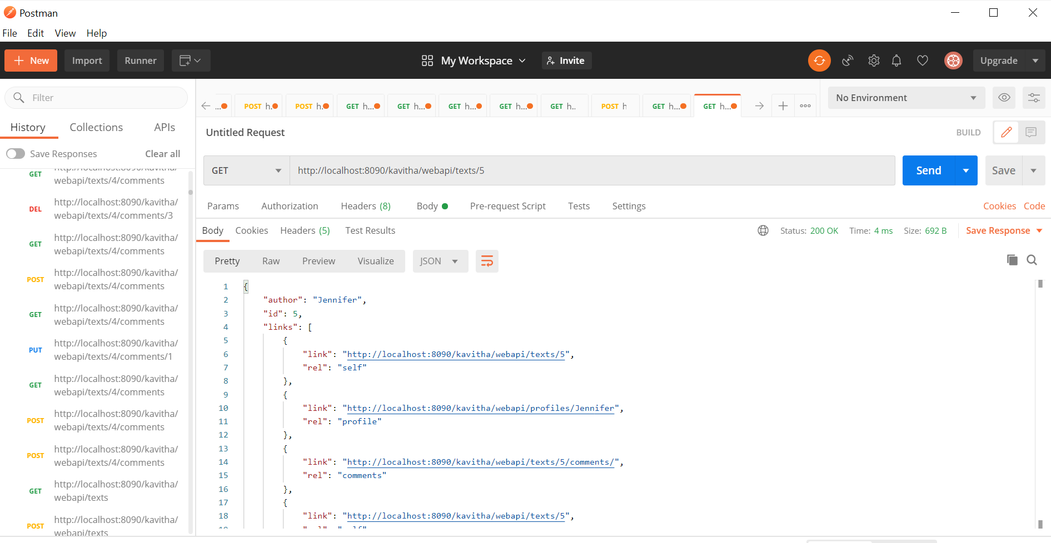

HATEOS for third message:

